***Maureen Kirk-Detberner***

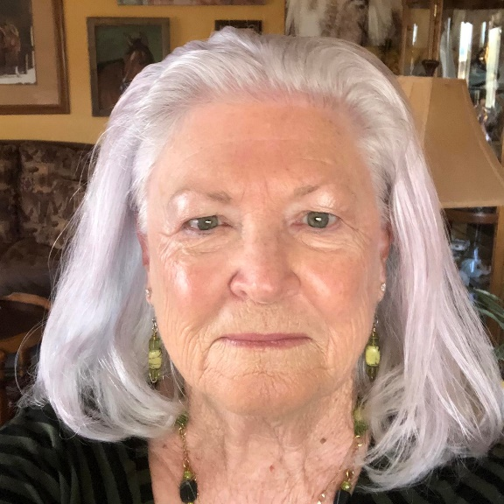Based in Green Valley, Arizona, Maureen Kirk-Detberner finds inspiration for her paintings in the local landscape, livestock and wild life. With her photos as references, she paints using both oil and acrylic paints. Maureen’s animal and human subjects are portrayed in a realistic style.

In her teen years, Maureen took an Art History class where she discovered an interest in art. That interest plus the degree requirements pushed her towards taking another art class. In 1965, her mother’s Christmas gift was set of oil paints. Maureen’s first attempt at an oil painting was a portrait of an older lady using a National Geographic cover photo as a reference.

After collage her life included marriage, children and a career in Health Care Information Technology that left no time art. Much later in 2017, Maureen decided to take a drawing class followed with an acrylic painting class at Toscana Studio and Gallery in Oro Valley, AZ. Now with her art skills refreshed and her painting confidence bolstered, she started art classes with Linda Ahern at Toscana Studio and Gallery.

Maureen started painting for her own pleasure and has entered her paintings in several local art shows in Tucson and Oro Valley, AZ. In 2020, with a move to Green Valley, her painting was again sidelined. It took some time but in 2023 Maureen found a strong desire to paint again. Her skills a bit rusty, she decided in to join the Santa Rita Art League and start showing her art again.

An accomplished photographer Maureen’s artwork is available for view on her website site MaureenKirkArt.com and purchase at her Etsy Shop MaureenKirkArt. Recently Maureen has started to use her photographs in Multi-Media art work.

Maureen’s accomplishments include:

* Painting “Ghost Dances” received third place in juried show **Visions Exhibit at the Community Performance & Art Center, Green Valley, Az.**
* Paintings “Alheri” received third place in the Santa Rita Art League’s 2023 juried Members Exhibit, March 2023, Green Valley, AZ.
* Painting “Winter Thoughts,” sold at Santa Rita Art League’s Permanent Show, January 2023.
* Digital art “Traditions” and “Ancient Soul” sold BUU Exhibits 2023.
* Digital art “The Race Is On” and “No Passing” sold, BUU Exhibits 2023.
* Several paintings accepted into juried Art Exhibits at Toscana Studio and Gallery.
* Her fine art photography and digital art has been featured on magazine covers, magazine and newspaper article and has won many local, national and international awards.
* Her work has hung at the SAAG Gallery, Tohono Chul Park's Gallery (photography), Claire's Cafe and Gallery, Toscana Studio and Gallery, Gourmet Girls Gluten Free Bakery/Bistro (photography), Roche, Sweet Poppies (photography) and others.